K. L. UNIVERSITY
FRESHMAN ENGINEERING DEPARTMENT

A Project Based Lab Report On
LIBRARY VAULT

SUBMITTED BY:
ID NUMBER NAME
2600031870 Ch. Charitha
2600031919 D. Vijaya Kumar
2600032149 P. Nitheesh Naidu
2600031984 B. Susan Shulamite

UNDER THE ESTEEMED GUIDEDIANCE OF
Dr. SIVA KUMAR
PROFESSOR



KL UNIVERSITY
Green fields, Vaddeswaram – 522 502 Guntur Dt., AP, India.

INDEX

DEPARTMENT OF BASIC ENGINEERING SCIENCES



CERTIFICATE

This is to certify that the project based laboratory report entitled “Library vault” submitted by Ch Charitha, D. Vijayakumar, P. Nitheesh Naidu , B. Susan Shulamite bearing Regd. No. 2600031870, 2600031919, 2600032149, 2600031984 to the Department of COMPUTER SICENCE ENGINEERING , KL University in partial fulfillment of the requirements for the completion of a project based Laboratory in “Problem Solving using Programming (JAVA)(26SC1101)” course in I B Tech I Semester, is a bonafede record of the work carried out by him/her under my supervision during the academic year 2026 – 2027.

PROJECT SUPERVISOR HEAD OF THE DEPARTMENT Dr. SIVA KUMAR Dr. D. HARITHA

ACKNOWLEDGEMENTS

It is great pleasure for me to express my gratitude to our honorable President.

Sri. Koneru Satyanarayana, for giving the opportunity and platform with facilities in accomplishing the project-based laboratory report.
I express sincere gratitude to our Director Dr. A. Jagdeesh for his administration towards our academic growth.
I express sincere gratitude to our Coordinator and HOD-BES Dr. D. Haritha for her leadership and constant motivation provided in successful completion of our academic semester. I record it as my privilege to deeply thank you for providing us with the efficient faculty and facilities to make our ideas into reality.
I express my sincere thanks to our project supervisor Dr. Siva Kumar Pathuri for his novel association of ideas, encouragement, appreciation, and intellectual zeal which motivated us to venture this project successfully.
Finally, we are pleased to acknowledge our indebtedness to all those who devoted themselves directly or indirectly to making this project a success.

Name: Ch Charitha
D. Vijaya Kumar
B. Susan Shulamite
P. Nitheesh

ID No: 2600031870
2600031919
2600031984
2600032149

ABSTRACT

Library Vault is a Java-based Library Management System designed to automate and simplify library operations in educational institutions. Traditional library management involves manual record-keeping, which can be time-consuming, difficult to maintain, and prone to errors. Library Vault aims to overcome these challenges by providing a structured and user-friendly system for managing books, members, librarians, and library transactions. The system helps maintain accurate records, track book availability, manage issue and return activities, calculate fines for overdue books, and generate useful reports. Its primary objective is to reduce manual effort, improve data accuracy, and enhance the overall efficiency of library administration.

The project is developed using Java and is divided into ten modules: Book Module, Member Module, Librarian Module, Issue and Return Module, Fine Module, ValidateService Module, SearchService Module, ReportGenerationService Module, AnalysisService Module, and Main Module. Each module performs a specific function, such as managing book and member records, maintaining librarian information, handling book transactions, calculating overdue fines, validating user inputs, searching for books and records, generating reports, and analyzing library activities. The Main Module coordinates the overall execution of the system and connects the different modules. By applying object-oriented programming concepts and modular design, Library Vault provides a maintainable and extensible solution for library management. The system can be further enhanced with database integration, user authentication, automated notifications, and advanced analytical features. Overall, Library Vault aims to make library operations more organized, reliable, and efficient.

INTRODUCTION

Library Vault is a newly designed Library Management System developed to make library operations faster, easier, and more organized. It is specially designed to manage books, members, and librarians efficiently while reducing the difficulties of traditional manual record-keeping. The system allows users to maintain book details, search for books, check their availability, and manage book issue and return activities. It also helps calculate fines for overdue books, validate the information entered, generate reports, and analyze library activities. The details of books, members, and transactions can be maintained systematically, making it easier to access and update records whenever required. The system is developed using Java and is divided into ten modules: Book Module, Member Module, Librarian Module, Issue and Return Module, Fine Module, ValidateService Module, SearchService Module, ReportGenerationService Module, AnalysisService Module, and Main Module. Each module performs a specific task and works together to ensure the smooth functioning of the application. Library Vault aims to minimize manual work, improve accuracy, save time, and provide a reliable solution for managing library resources.
Features of Library Vault:
- Easy to use and understand.
- Organized management of books, members, and librarians.
- Quick searching and tracking of book availability.
- Efficient book issue and return management.
- Automatic fine calculation for overdue books.
- Validation of user inputs and library records.
- Report generation and analysis of library activities.

AIM

The main purpose of Library Vault is to provide an efficient and user-friendly system for managing library activities. It is designed to automate the process of maintaining book records, managing members and librarians, issuing and returning books, and calculating fines for overdue books. The system helps users search for books and check their availability easily. It also validates the information entered, generates reports, and analyzes library activities, thereby reducing manual work and minimizing errors. By maintaining organized records, Library Vault makes library operations faster, more accurate, and reliable.
The aims of this project are:
→ To provide an efficient and organized library management system.
→ To simplify the management of books, members, and librarians.
→ To automate book issue, return, and fine calculation processes.
→ To enable quick searching and tracking of book availability.
→ To reduce manual paperwork and minimize human errors.
→ To generate reports and analyze library activities efficiently.

ADVANTAGES
• It reduces paperwork and saves time by maintaining library records systematically.
• It provides easy book searching and availability tracking.
• It improves accuracy in book issue, return, and fine calculations.
• It helps manage book, member, and librarian information efficiently.
• It generates reports and supports the analysis of library activities.

DISADVANTAGES
• The system requires regular maintenance and proper data management.
• Incorrect input data may lead to inaccurate records and reports.
• Data may be lost if proper backup facilities are not maintained.
• Users may require basic computer knowledge to operate the system.

FUTURE IMPLEMENTATION

Library Vault can be enhanced by integrating a database to store records permanently and securely. Online access, user authentication, automated due-date reminders, barcode scanning, and advanced report generation can be introduced in the future. The system can also include book reservation facilities and graphical analysis of library activities to make library management more convenient and efficient.

SYSTEM REQUIREMENTS

SOFTWARE REQUIREMENTS

The major software requirements of the project are as follows:

Language: Java.

Operating System: Windows 10 or above.

IDE: Eclipse IDE or any Java-supported IDE.

JDK: Java Development Kit (JDK 17 or above).

Technical Requirements: Java compiler, keyboard, mouse, and monitor.
- .

HARDWARE REQUIREMENTS:

RAM: 4 GB minimum (8 GB recommended).

Processor: Intel Core i3 or above.

Hard Disk: At least 500 MB of free space for the project files and development tools.

Input Devices: Keyboard and mouse.

Output Device: Monitor or display screen.

FUTURE IMPLEMENTATION:
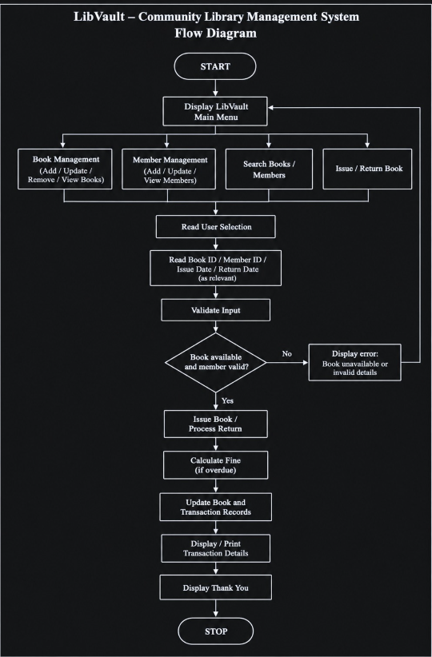

ALGORITHM
Step 1: Start the Library Vault application.
Step 2: Initialize the Main Module and display the menu containing all library operations.
Step 3: Select the required operation from the menu.
Step 4: Execute the Book Module to add, update, delete, view, and manage book details.
Step 5: Execute the Member Module to register, update, delete, and view member information.
Step 6: Execute the Librarian Module to manage librarian details and records.
Step 7: Execute the Issue and Return Module to issue books, process returns, update book availability, and maintain due dates.
Step 8: Execute the Fine Module to calculate overdue fines and maintain fine records.
Step 9: Use the ValidateService Module to validate member IDs, book IDs, email addresses, and fine amounts.
Step 10: Use the SearchService Module to search for books, members, librarians, and transaction records.
Step 11: Use the ReportGenerationService Module to generate reports related to books, members, issues, returns, and fines.
Step 12: Use the AnalysisService Module to analyze library activities, book usage, and transaction records.
Step 13: Display the results of the selected operation and return to the Main Module if another operation is required.
Step 14: If the user chooses to exit, close the application.
Step 15: Stop.

IMPLEMENTATION

MODULE 1: Book Java

package LibVault;

import java.util.ArrayList;

import java.util.List;

import java.util.Scanner;

public class SearchServiceMain {

public static void main(String[] args) {

Scanner sc = new Scanner(System.in);

List<Book> bookList = new ArrayList<>();

List<Member> memberList = new ArrayList<>();

List<Librarian> librarianList = new ArrayList<>();

List<IssueReturn> transactionList = new ArrayList<>();

SearchService search = new SearchService(

bookList,

memberList,

librarianList,

transactionList

);

System.out.println("================================");

System.out.println(" LIBVAULT SEARCH");

System.out.println("================================");

System.out.println("\n1. Search Book by ID");

System.out.println("2. Search Book by Title");

System.out.println("3. Search Member");

System.out.println("4. Search Librarian");

System.out.println("5. Search Transaction");

System.out.print("\nEnter your choice: ");

int choice = sc.nextInt();

sc.nextLine();

if (choice == 1) {

System.out.print("Enter Book ID: ");

int id = sc.nextInt();

search.searchBookById(id);

} else if (choice == 2) {

System.out.print("Enter Book Title: ");

String title = sc.nextLine();

search.searchBookByTitle(title);

} else if (choice == 3) {

System.out.print("Enter Member ID: ");

int id = sc.nextInt();

search.searchMember(id);

} else if (choice == 4) {

System.out.print("Enter Librarian ID: ");

int id = sc.nextInt();

search.searchLibrarian(id);

} else if (choice == 5) {

System.out.print("Enter Transaction ID: ");

int id = sc.nextInt();

search.searchTransaction(id);

} else {

System.out.println("Invalid choice!");

}

sc.close();

}

}

package LibVault;

public class BookMain {

public static void main(String[] args) {

Book b = new Book();

b.addBook();

b.displayBook();

b.updateBook();

b.displayBook();

b.removeBook();

b.displayBook();

}

}

MODULE 2: Member Java

package LibVault;

import java.util.Scanner;

public class Member {

int memberId;

String memberName;

String department;

String email;

long mobileNumber;

Scanner sc = new Scanner(System.in);

public void registerMember() {

System.out.print("Enter Member ID: ");

memberId = sc.nextInt();

sc.nextLine();

System.out.print("Enter Member Name: ");

memberName = sc.nextLine();

System.out.print("Enter Department: ");

department = sc.nextLine();

System.out.print("Enter Email: ");

email = sc.nextLine();

System.out.print("Enter Mobile Number: ");

mobileNumber = sc.nextLong();

System.out.println("Member registered successfully!");

}

public void updateMember() {

sc.nextLine();

System.out.print("Enter new name: ");

memberName = sc.nextLine();

System.out.print("Enter new department: ");

department = sc.nextLine();

System.out.print("Enter new email: ");

email = sc.nextLine();

System.out.print("Enter new mobile number: ");

mobileNumber = sc.nextLong();

System.out.println("Member updated successfully!");

}

public void displayMember() {

System.out.println("\n--- Member Details ---");

System.out.println("Member ID: " + memberId);

System.out.println("Name: " + memberName);

System.out.println("Department: " + department);

System.out.println("Email: " + email);

System.out.println("Mobile: " + mobileNumber);

}

}

package LibVault;

import java.util.Scanner;

public class MemberMain {

public static void main(String[] args) {

Scanner sc=new Scanner(System.in);

Member member = new Member();

System.out.println("================================");

System.out.println(" LIBVAULT MEMBER");

System.out.println("================================");

System.out.println("\n1. Register Member");

System.out.println("2. Update Member");

System.out.println("3. Display Member");

System.out.print("\nEnter your choice: ");

int choice = sc.nextInt();

if (choice == 1) {

member.registerMember();

member.displayMember();

} else if (choice == 2) {

member.updateMember();

member.displayMember();

} else if (choice == 3) {

member.displayMember();

} else {

System.out.println("Invalid choice!");

}

sc.close();

}

}

MODULE 3:Librarian Java

package LibVault;

import java.util.Scanner;

public class Librarian {

int librarianId;

String librarianName;

String designation;

String email;

Scanner sc = new Scanner(System.in);

public void addLibrarian() {

System.out.print("Enter Librarian ID: ");

librarianId = sc.nextInt();

sc.nextLine();

System.out.print("Enter Librarian Name: ");

librarianName = sc.nextLine();

System.out.print("Enter Designation: ");

designation = sc.nextLine();

System.out.print("Enter Email: ");

email = sc.nextLine();

System.out.println("Librarian added successfully!");

}

public void updateLibrarian() {

sc.nextLine();

System.out.print("Enter new name: ");

librarianName = sc.nextLine();

System.out.print("Enter new designation: ");

designation = sc.nextLine();

System.out.print("Enter new email: ");

email = sc.nextLine();

System.out.println("Librarian updated successfully!");

}

public void displayLibrarian() {

System.out.println("\n--- Librarian Details ---");

System.out.println("Librarian ID: " + librarianId);

System.out.println("Name: " + librarianName);

System.out.println("Designation: " + designation);

System.out.println("Email: " + email);

}

}

package LibVault;

public class LibrarianMain {

public static void main(String[] args) {

Librarian librarian = new Librarian();

System.out.println("================================");

System.out.println(" LIBVAULT LIBRARIAN");

System.out.println("================================");

System.out.println("\n1. Add Librarian");

System.out.println("2. Update Librarian");

System.out.println("3. Display Librarian");

System.out.print("\nEnter your choice: ");

int choice = librarian.sc.nextInt();

if (choice == 1) {

librarian.addLibrarian();

librarian.displayLibrarian();

} else if (choice == 2) {

librarian.updateLibrarian();

librarian.displayLibrarian();

} else if (choice == 3) {

librarian.displayLibrarian();

} else {

System.out.println("Invalid choice!");

}

}

}

MODULE 4: Issue And Return Java

package LibVault;

import java.util.Scanner;

public class IssueReturn {

int transactionId;

int memberId;

int bookId;

String issueDate;

String returnDate;

Scanner sc = new Scanner(System.in);

public void issueBook() {

System.out.print("Enter Transaction ID: ");

transactionId = sc.nextInt();

System.out.print("Enter Member ID: ");

memberId = sc.nextInt();

System.out.print("Enter Book ID: ");

bookId = sc.nextInt();

sc.nextLine();

System.out.print("Enter Issue Date: ");

issueDate = sc.nextLine();

returnDate = "Not Returned";

System.out.println("Book issued successfully!");

}

public void returnBook() {

sc.nextLine();

System.out.print("Enter Return Date: ");

returnDate = sc.nextLine();

System.out.println("Book returned successfully!");

}

public void renewBook() {

sc.nextLine();

System.out.print("Enter new return date: ");

returnDate = sc.nextLine();

System.out.println("Book renewed successfully!");

}

public void displayTransaction() {

System.out.println("\n--- Transaction Details ---");

System.out.println("Transaction ID: " + transactionId);

System.out.println("Member ID: " + memberId);

System.out.println("Book ID: " + bookId);

System.out.println("Issue Date: " + issueDate);

System.out.println("Return Date: " + returnDate);

}

}

package LibVault;

public class IssueReturnMain {

public static void main(String[] args) {

IssueReturn transaction = new IssueReturn();

System.out.println("================================");

System.out.println(" LIBVAULT ISSUE & RETURN");

System.out.println("================================");

System.out.println("\n1. Issue Book");

System.out.println("2. Return Book");

System.out.println("3. Renew Book");

System.out.println("4. Display Transaction");

System.out.print("\nEnter your choice: ");

int choice = transaction.sc.nextInt();

if (choice == 1) {

transaction.issueBook();

transaction.displayTransaction();

} else if (choice == 2) {

transaction.returnBook();

transaction.displayTransaction();

} else if (choice == 3) {

transaction.renewBook();

transaction.displayTransaction();

} else if (choice == 4) {

transaction.displayTransaction();

} else {

System.out.println("Invalid choice!");

}

}

}

MODULE 5: Fine java

package LibVault;

import java.util.Scanner;

public class Fine {

int fineId;

int transactionId;

double fineAmount;

String paymentStatus;

Scanner sc = new Scanner(System.in);

public void calculateFine() {

System.out.print("Enter Fine ID: ");

fineId = sc.nextInt();

System.out.print("Enter Transaction ID: ");

transactionId = sc.nextInt();

System.out.print("Enter Fine Amount: ");

fineAmount = sc.nextDouble();

paymentStatus = "Pending";

System.out.println("Fine calculated: Rs." + fineAmount);

}

public void collectFine() {

paymentStatus = "Paid";

System.out.println("Fine collected successfully!");

}

public void displayFine() {

System.out.println("\n--- Fine Details ---");

System.out.println("Fine ID: " + fineId);

System.out.println("Transaction ID: " + transactionId);

System.out.println("Fine Amount: Rs." + fineAmount);

System.out.println("Payment Status: " + paymentStatus);

}

}

package LibVault;

public class FineMain {

public static void main(String[] args) {

Fine fine = new Fine();

System.out.println("================================");

System.out.println(" LIBVAULT FINE");

System.out.println("================================");

System.out.println("\n1. Calculate Fine");

System.out.println("2. Collect Fine");

System.out.println("3. Display Fine");

System.out.print("\nEnter your choice: ");

int choice = fine.sc.nextInt();

if (choice == 1) {

fine.calculateFine();

fine.displayFine();

} else if (choice == 2) {

fine.collectFine();

fine.displayFine();

} else if (choice == 3) {

fine.displayFine();

} else {

System.out.println("Invalid choice!");

}

}

}

MODULE 6: Validate Service java

package LibVault;

public class ValidateService {

int memberId;

int bookId;

String email;

double fineAmount;

public boolean validateMemberId(int memberId) {

return memberId > 0;

}

public boolean validateBookId(int bookId) {

return bookId > 0;

}

public boolean eEmail(String email) {

return email != null && email.contains("@") && email.contains(".");

}

public boolean validateFineAmount(double fineAmount) {

return fineAmount >= 0;

}

public boolean validateEmail(String email2) {

// TODO Auto-generated method stub

return false;

}

}

package LibVault;

import java.util.Scanner;

public class ValidateServiceMain {

public static void main(String[] args) {

Scanner sc = new Scanner(System.in);

ValidateService validate = new ValidateService();

System.out.println("================================");

System.out.println(" LIBVAULT VALIDATION");

System.out.println("================================");

System.out.print("Enter Member ID: ");

int memberId = sc.nextInt();

if (validate.validateMemberId(memberId)) {

System.out.println("Valid Member ID");

} else {

System.out.println("Invalid Member ID");

}

System.out.print("\nEnter Book ID: ");

int bookId = sc.nextInt();

if (validate.validateBookId(bookId)) {

System.out.println("Valid Book ID");

} else {

System.out.println("Invalid Book ID");

}

MODULE 7: Search Service

package LibVault;

import java.util.List;

public class SearchService {

List<Book> bookList;

List<Member> memberList;

List<Librarian> librarianList;

List<IssueReturn> transactionList;

public SearchService(List<Book> bookList,

List<Member> memberList,

List<Librarian> librarianList,

List<IssueReturn> transactionList) {

this.bookList = bookList;

this.memberList = memberList;

this.librarianList = librarianList;

this.transactionList = transactionList;

}

public void searchBookById(int id) {

for (Book book : bookList) {

if (book.bookId == id) {

book.displayBook();

return;

}

}

System.out.println("Book not found!");

}

public void searchBookByTitle(String title) {

for (Book book : bookList) {

if (book.title.equalsIgnoreCase(title)) {

book.displayBook();

}

}

}

public void searchMember(int id) {

for (Member member : memberList) {

if (member.memberId == id) {

member.displayMember();

return;

}

}

System.out.println("Member not found!");

}

public void searchTransaction(int id) {

for (IssueReturn transaction : transactionList) {

if (transaction.transactionId == id) {

transaction.displayTransaction();

return;

}

}

System.out.println("Transaction not found!");

}

public void searchLibrarian(int id) {

// TODO Auto-generated method stub

}

}

package LibVault;

import java.util.ArrayList;

import java.util.List;

import java.util.Scanner;

public class SearchServiceMain {

public static void main(String[] args) {

Scanner sc = new Scanner(System.in);

List<Book> bookList = new ArrayList<>();

List<Member> memberList = new ArrayList<>();

List<Librarian> librarianList = new ArrayList<>();

List<IssueReturn> transactionList = new ArrayList<>();

SearchService search = new SearchService(

bookList,

memberList,

librarianList,

transactionList

);

System.out.println("================================");

System.out.println(" LIBVAULT SEARCH");

System.out.println("================================");

System.out.println("\n1. Search Book by ID");

System.out.println("2. Search Book by Title");

System.out.println("3. Search Member");

System.out.println("4. Search Librarian");

System.out.println("5. Search Transaction");

System.out.print("\nEnter your choice: ");

int choice = sc.nextInt();

sc.nextLine();

if (choice == 1) {

System.out.print("Enter Book ID: ");

int id = sc.nextInt();

search.searchBookById(id);

} else if (choice == 2) {

System.out.print("Enter Book Title: ");

String title = sc.nextLine();

search.searchBookByTitle(title);

} else if (choice == 3) {

System.out.print("Enter Member ID: ");

int id = sc.nextInt();

search.searchMember(id);

} else if (choice == 4) {

System.out.print("Enter Librarian ID: ");

int id = sc.nextInt();

search.searchLibrarian(id);

} else if (choice == 5) {

System.out.print("Enter Transaction ID: ");

int id = sc.nextInt();

search.searchTransaction(id);

} else {

System.out.println("Invalid choice!");

}

sc.close();

}

}

MODULE 8: Report Generation Service

package LibVault;

import java.util.List;

public class ReportGenerationService {

Book book;

Member member;

IssueReturn transaction;

String reportTitle;

public void generateBookReport(List<Book> bookList) {

reportTitle = "BOOK INVENTORY REPORT";

System.out.println("\n========== " + reportTitle + " ==========");

for (Book b : bookList) {

b.displayBook();

}

}

public void generateMemberReport(List<Member> memberList) {

reportTitle = "MEMBER REPORT";

System.out.println("\n========== " + reportTitle + " ==========");

for (Member m : memberList) {

m.displayMember();

}

}

public void generateIssueReport(List<IssueReturn> transactionList) {

reportTitle = "ISSUE REPORT";

System.out.println("\n========== " + reportTitle + " ==========");

for (IssueReturn t : transactionList) {

t.displayTransaction();

}

}

public void generateFineReport(List<Fine> fineList) {

reportTitle = "FINE REPORT";

System.out.println("\n========== " + reportTitle + " ==========");

for (Fine f : fineList) {

f.displayFine();

}

}

}
package LibVault;

import java.util.ArrayList;

import java.util.List;

import java.util.Scanner;

public class ReportGenerationServiceMain {

public static void main(String[] args) {

Scanner sc = new Scanner(System.in);

List<Book> bookList = new ArrayList<>();

List<Member> memberList = new ArrayList<>();

List<IssueReturn> transactionList = new ArrayList<>();

List<Fine> fineList = new ArrayList<>();

ReportGenerationService report =

new ReportGenerationService();

System.out.println("================================");

System.out.println(" LIBVAULT REPORTS");

System.out.println("================================");

System.out.println("\n1. Book Report");

System.out.println("2. Member Report");

System.out.println("3. Issue Report");

System.out.println("4. Fine Report");

System.out.print("\nEnter your choice: ");

int choice = sc.nextInt();

if (choice == 1) {

report.generateBookReport(bookList);

} else if (choice == 2) {

report.generateMemberReport(memberList);

} else if (choice == 3) {

report.generateIssueReport(transactionList);

} else if (choice == 4) {

report.generateFineReport(fineList);

} else {

System.out.println("Invalid choice!");

}

sc.close();

}

}

MODULE 9: Analysis Service Java

package LibVault;
import java.util.List;
import java.util.Map;
import java.util.HashMap;
import java.util.stream.Collectors;

public class AnalysisService {

List<Book> bookList;
List<IssueReturn> transactionList;
Map<String, Integer> categoryMap;

public AnalysisService(List<Book> bookList,
List<IssueReturn> transactionList) {

this.bookList = bookList;
this.transactionList = transactionList;
categoryMap = new HashMap<>();
}

public void categoryWiseAnalysis() {

categoryMap = bookList.stream()
.collect(Collectors.groupingBy(
b -> b.category,
Collectors.collectingAndThen(
Collectors.counting(),
Long::intValue
)
));

System.out.println("\n--- Category Wise Analysis ---");

for (Map.Entry<String, Integer> entry : categoryMap.entrySet()) {
System.out.println(
entry.getKey() + " : " + entry.getValue()
);
}
}

public void findMostIssuedBook() {

if (transactionList.isEmpty()) {
System.out.println("No transaction records available.");
return;
}

Map<Integer, Long> count = transactionList.stream()
.collect(Collectors.groupingBy(
t -> t.bookId,
Collectors.counting()
));

int mostIssuedBook = count.entrySet()
.stream()
.max(Map.Entry.comparingByValue())
.get()
.getKey();

System.out.println(
"Most Issued Book ID: " + mostIssuedBook
);
}

public void calculateFineCollection(List<Fine> fineList) {

double total = fineList.stream()
.filter(f -> f.paymentStatus.equalsIgnoreCase("Paid"))
.mapToDouble(f -> f.fineAmount)
.sum();

System.out.println("Total Fine Collected: Rs." + total);
}

public void generateSummary(List<Member> memberList) {
System.out.println("\n========== LIBRARY SUMMARY ==========");
System.out.println("Total Books: " + bookList.size());
System.out.println("Total Members: " + memberList.size());
System.out.println("Total Transactions: " + transactionList.size());
}
}

package LibVault;
import java.util.ArrayList;
import java.util.List;
import java.util.Scanner;

public class AnalysisServiceMain {
public static void main(String[] args) {

Scanner sc = new Scanner(System.in);

List<Book> bookList = new ArrayList<>();
List<IssueReturn> transactionList = new ArrayList<>();
List<Member> memberList = new ArrayList<>();
List<Fine> fineList = new ArrayList<>();

// Add sample books
Book b1 = new Book();
b1.bookId = 101;
b1.title = "Java Programming";
b1.category = "Programming";
bookList.add(b1);

Book b2 = new Book();
b2.bookId = 102;
b2.title = "Python Programming";
b2.category = "Programming";
bookList.add(b2);

Book b3 = new Book();
b3.bookId = 103;
b3.title = "English Grammar";
b3.category = "Education";
bookList.add(b3);

// Add sample transactions
IssueReturn t1 = new IssueReturn();
t1.transactionId = 1;
t1.bookId = 101;
transactionList.add(t1);

IssueReturn t2 = new IssueReturn();
t2.transactionId = 2;
t2.bookId = 101;
transactionList.add(t2);

IssueReturn t3 = new IssueReturn();
t3.transactionId = 3;
t3.bookId = 102;
transactionList.add(t3);

// Add a sample member
Member m1 = new Member();
m1.memberId = 201;
memberList.add(m1);

// Add a sample fine
Fine f1 = new Fine();
f1.fineId = 1;
f1.transactionId = 1;
f1.fineAmount = 50;
f1.paymentStatus = "Paid";
fineList.add(f1);

AnalysisService analysis =
new AnalysisService(bookList, transactionList);

System.out.println("==================================");
System.out.println(" LIBVAULT ANALYSIS");
System.out.println("==================================");

System.out.println("\n1. Category-wise Analysis");
System.out.println("2. Find Most Issued Book");
System.out.println("3. Calculate Fine Collection");
System.out.println("4. Generate Library Summary");

System.out.print("\nEnter your choice: ");
int choice = sc.nextInt();

switch (choice) {

case 1:
analysis.categoryWiseAnalysis();
break;

case 2:
analysis.findMostIssuedBook();
break;

case 3:
analysis.calculateFineCollection(fineList);
break;

case 4:
analysis.generateSummary(memberList);
break;

default:
System.out.println("Invalid choice!");
}

sc.close();
}
}
MODULE 10: MAIN JAVA

package LibVault;
import java.util.ArrayList;
import java.util.Scanner;

public class Main {

static Scanner scanner = new Scanner(System.in);

static ArrayList<Book> bookList = new ArrayList<>();
static ArrayList<Member> memberList = new ArrayList<>();
static ArrayList<Librarian> librarianList = new ArrayList<>();
static ArrayList<IssueReturn> transactionList = new ArrayList<>();
static ArrayList<Fine> fineList = new ArrayList<>();

public static void main(String[] args) {

int choice;

do {

displayMenu();

System.out.print("Enter your choice: ");
choice = scanner.nextInt();

processChoice(choice);

} while (choice != 0);

exit();
}

public static void displayMenu() {

System.out.println("\n==================================");
System.out.println(" LIBVAULT LIBRARY SYSTEM");
System.out.println("==================================");

System.out.println("1. Add Book");
System.out.println("2. Display Books");
System.out.println("3. Register Member");
System.out.println("4. Display Members");
System.out.println("5. Add Librarian");
System.out.println("6. Issue Book");
System.out.println("7. Return Book");
System.out.println("8. Calculate Fine");
System.out.println("9. Collect Fine");
System.out.println("10. Search Book");
System.out.println("11. Search Member");
System.out.println("12. Book Report");
System.out.println("13. Member Report");
System.out.println("14. Issue Report");
System.out.println("15. Category Analysis");
System.out.println("16. Library Summary");
System.out.println("0. Exit");

System.out.println("==================================");
}

public static void processChoice(int choice) {

switch (choice) {

case 1:

Book book = new Book();
book.addBook();
bookList.add(book);

break;

case 2:

for (Book b : bookList) {
b.displayBook();
}

break;

case 3:

Member member = new Member();
member.registerMember();
memberList.add(member);

break;

case 4:

for (Member m : memberList) {
m.displayMember();
}

break;

case 5:

Librarian librarian = new Librarian();
librarian.addLibrarian();
librarianList.add(librarian);

break;

case 6:

IssueReturn issue = new IssueReturn();
issue.issueBook();
transactionList.add(issue);

break;

case 7:

if (!transactionList.isEmpty()) {

transactionList
.get(transactionList.size() - 1)
.returnBook();

} else {

System.out.println("No transactions available.");
}

break;

case 8:

Fine fine = new Fine();
fine.calculateFine();
fineList.add(fine);

break;

case 9:

if (!fineList.isEmpty()) {

fineList
.get(fineList.size() - 1)
.collectFine();

} else {

System.out.println("No fine records available.");
}

break;

case 10:

System.out.print("Enter Book ID: ");
int bookId = scanner.nextInt();

SearchService searchBook =
new SearchService(
bookList,
memberList,
librarianList,
transactionList
);

searchBook.searchBookById(bookId);

break;

case 11:

System.out.print("Enter Member ID: ");
int memberId = scanner.nextInt();

SearchService searchMember =
new SearchService(
bookList,
memberList,
librarianList,
transactionList
);

searchMember.searchMember(memberId);

break;

case 12:

ReportGenerationService bookReport =
new ReportGenerationService();

bookReport.generateBookReport(bookList);

break;

case 13:

ReportGenerationService memberReport =
new ReportGenerationService();

memberReport.generateMemberReport(memberList);

break;

case 14:

ReportGenerationService issueReport =
new ReportGenerationService();

issueReport.generateIssueReport(transactionList);

break;

case 15:

AnalysisService analysis =
new AnalysisService(
bookList,
transactionList
);

analysis.categoryWiseAnalysis();

break;

case 16:

AnalysisService summary =
new AnalysisService(
bookList,
transactionList
);

summary.generateSummary(memberList);

break;

case 0:
break;

default:

System.out.println("Invalid choice!");
}
}

public static void exit() {

System.out.println("\nThank you for using LibVault!");
System.out.println("Application closed.");
}
}

INTEGRATION AND SYSTEM TESTING
OUTPUTS

Screen Shorts
Book module:

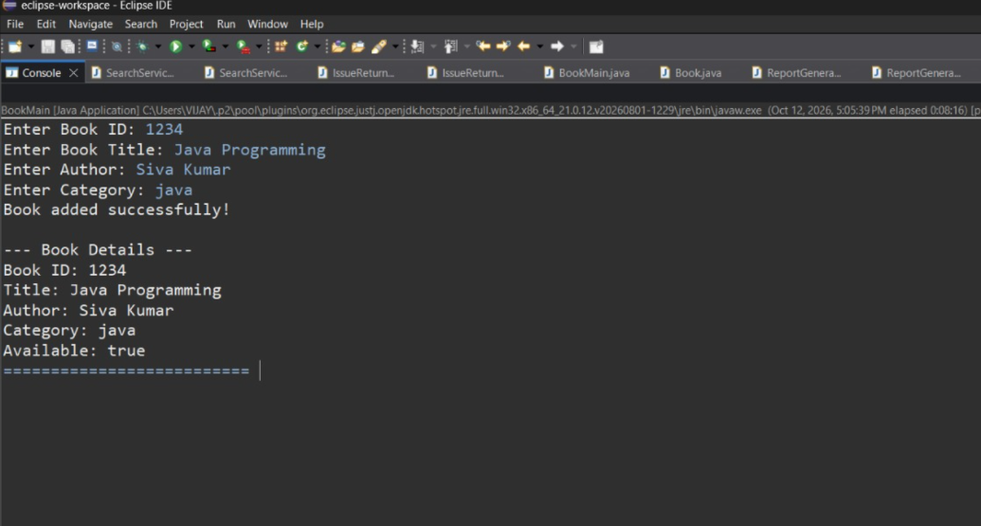

Member Module:

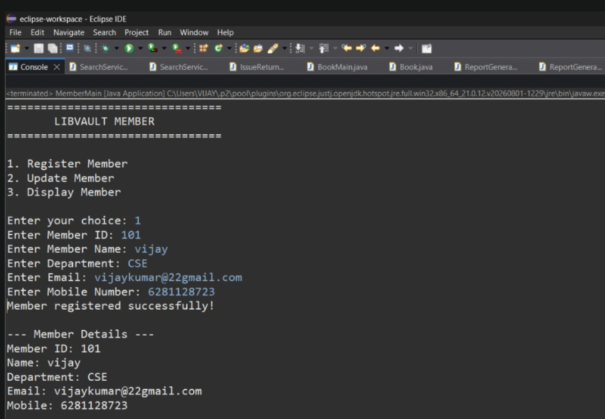

17

Librarian module:

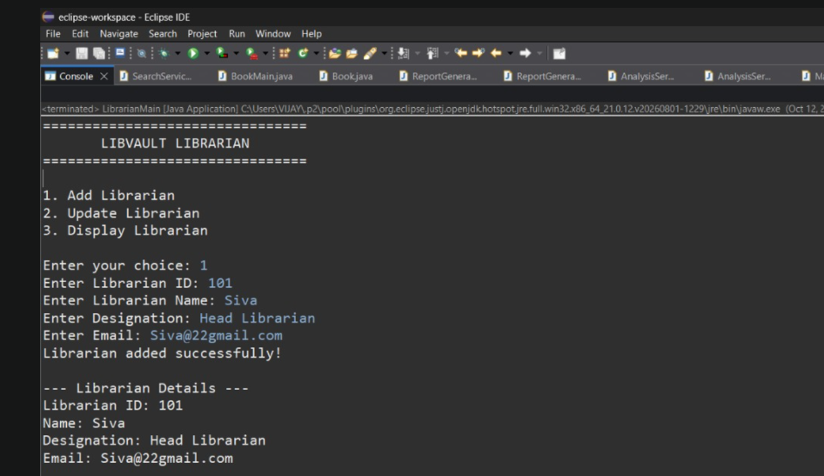

Issue Return Module:

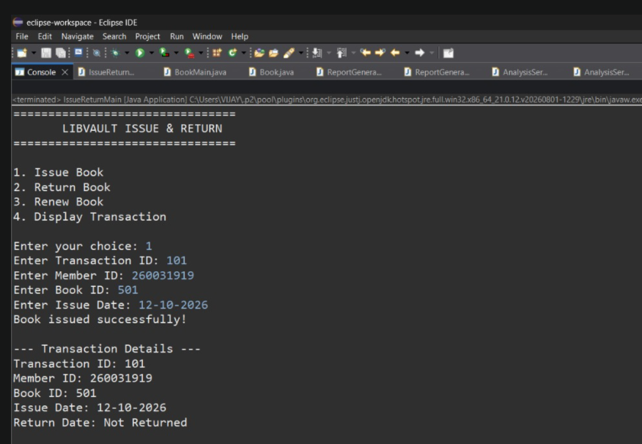

Fine Module:

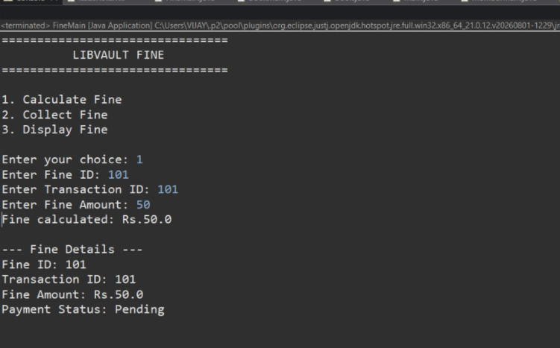

Validate Service Module:

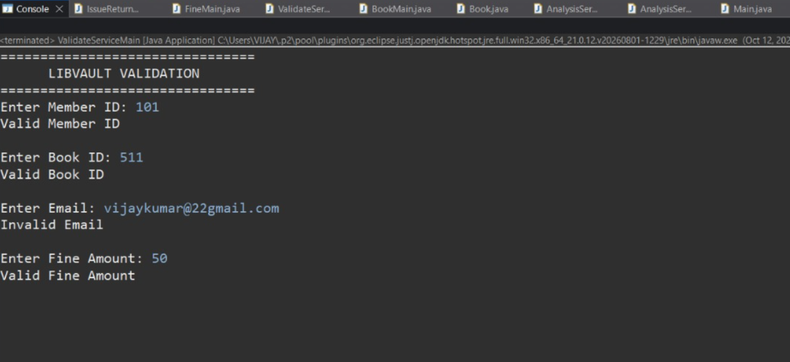

Search Service Module:
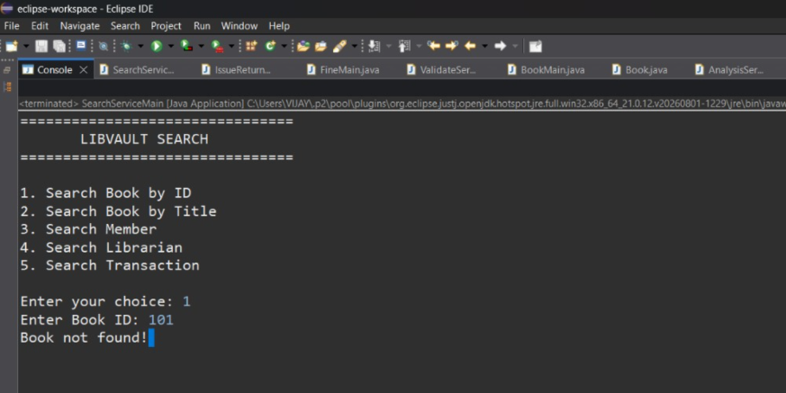

Report Generation Service Module:

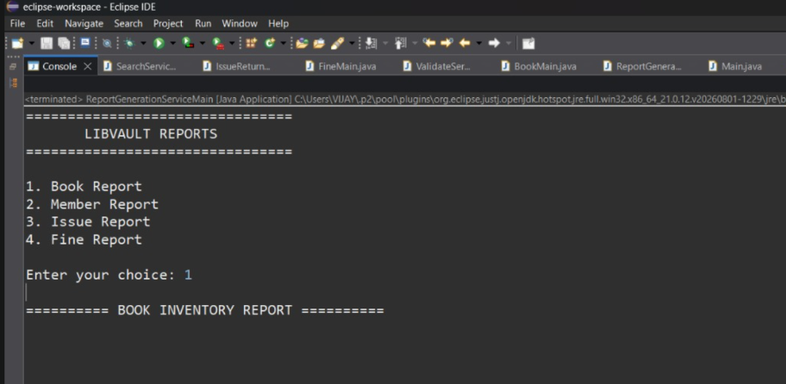

Analysis Service Module:

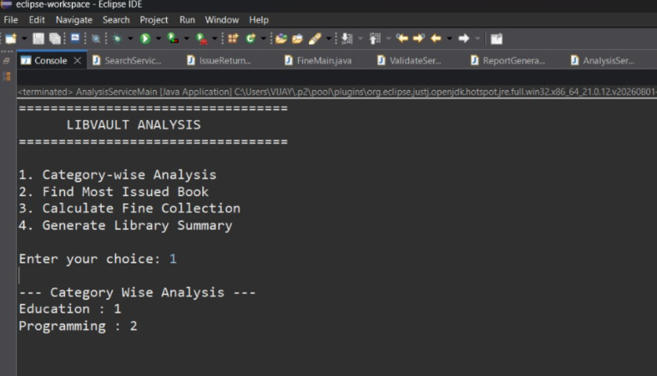

Main Module:

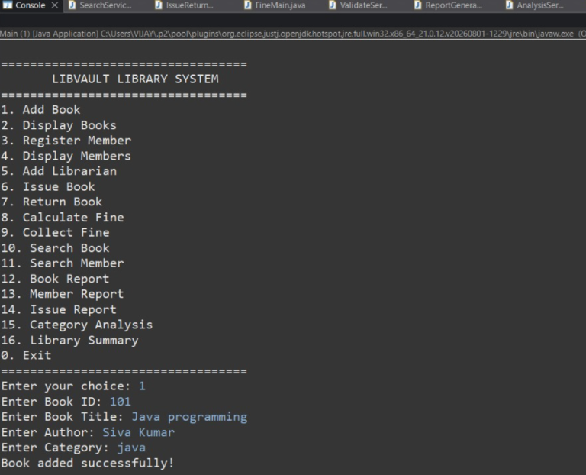

CONCLUSION
Library Vault is a Java-based Library Management System that simplifies book management, member registration, book issue and return, and fine calculation. Its ten modules help maintain organized records, reduce manual work, and improve accuracy. The project demonstrates the practical use of Java programming concepts and can be enhanced in the future with database integration and automated notifications.

